Nom et prénom du coordinateur / coordinator’s name |  | Attaccalite Claudio
Acronyme / Acronym |  | VELOCE
Titre de la proposition de projet |  | Ultrafast and non-linear phenomena at the nano-scale
Proposal title |  | Ultrafast and non-linear phenomena at the nano-scale
Comité d’évaluation / Evaluation committee |  | SIMI 4 – Physique
Type de recherche / Type of research |  | x Recherche Fondamentale / Basic Research  ◻ Recherche Industrielle / Industrial Research  ◻ Développement Expérimental / Experimental Development
Aide totale demandée / Grant requested | 115 € |  | Durée de la proposition de projet / Proposal duration | 36 mois

1. Résume de la proposition de projet / Proposal abstract 3
2. Contexte, positionnement et objectifs de la proposition / Context, positionning and objectives of the proposal 3
2.1. Contexte de la proposition de projet / Context of the proposal 3
2.2. État de l'art et position de la proposition de projet/state of the art and positionning of the proposal 7
2.3. Objectifs et caractère ambitieux et/ou novateur de la proposition de projet / Objectives, originality and/ or novelty of the proposal 9
3. Programme scientifique et technique, organisation de la proposition de projet / Scientific and technical programme, Proposal organisation 12
3.1. Programme scientifique et structuration de la proposition de projet/ Scientific programme, proposal structure 12
3.2. Description des travaux par tâche / Description by task 12
3.3. Calendrier des tâches, livrables et jalons / Tasks schedule, deliverables and milestones 16
4. Stratégie de valorisation, de protection et d’exploitation des résultats / Dissemination and exploitation of results, intellectual property 16
5. Description du partenariat / Consortium description 17
5.1. Description, adéquation et complémentarité des participants / Partners description and relevance, complementarity 17
5.2. Qualification du coordinateur de la proposition de projet/ Qualification of the proposal coordinator 17
5.3. Qualification, rôle et implication des participants / Qualification and contribution of each partner 18
6. Justification scientifique des moyens demandés / Scientific justification of requested ressources 18
6.1. Partenaire 1 / Partner 1 : Institut Neel 18
7. Annexes / Annexes 18
7.1. Références bibliographiques / References 18
7.2. Biographies / CV, resume 20
7.3. Implication des personnes dans d’autres contrats / Staff involvment in other contracts 21

Résume de la proposition de projet / Proposal abstract

Ultrafast atomic and electronic dynamics in strong laser fields has recently attracted increasing attention experimentally, fuelled by the tremendous progress in femtosecond laser technology. Modern lasers routinely provide pulse durations less than 10 femtoseconds, which is shorter than the vibrational time scale of even the fastest molecular systems, and power flux densities exceeding 10¹⁸ watts/cm2. This is opening incredible scenarios, creating new subfields of physics and chemistry. The use of ultrafast and ultra-intense laser fields in the nanoscience allows, for the first time, to understand processes at short times and small dimensions. This is substantially busting the search for new and technologically relevant applications like optical switches, nano-scale light-emitting diodes and efficient photocatalyzers.

The revolutionary perspectives of a massive use of nano-devices has inspired the development of new and accurate experimental techniques. However, although nano-scale components promise to revolutionize the electronics industry, making such devices will require an extremely detailed knowledge of the dynamics of charge carriers on nanometre length scales and subpicosecond time scales.

In front of the rapid development of the experimental techniques, the state-of-the-art theoretical approaches and numerical tools are in stringent delay. Up-to-date techniques, grounded on ad-hoc models are neither predictive nor universal. More importantly nanostructures are unavoidably ruled out by these methods. The theory is, thus, deprived of its predictive aspiration, and of the possibility of inspiring new experiments and practical applications. Instead, the continuous advent of more refined and accurate experimental techniques is unavoidably creating a gap between theory and experiment, that the VELOCE project aims to fill.

The main objective of the VELOCE project is, indeed, to provide an accurate, predictive and universal approach to the ultra-fast dynamics of electrons and atoms at the nano-scale. We will devise novel theoretical and methodological schemes suitable for studying nanostructures coupled with fast and strong laser fields. The VELOCE project will provide the scientific community with an unique suite of theoretical and numerical tools to support existing experiments and to inspire new applications.

Contexte, positionnement et objectifs de la proposition / Context, positionning and objectives of the proposal

Contexte de la proposition de projet / Context of the proposal
The measurement of short time intervals during the first half of the 20th century was limited to intervals longer than one nanosecond. Nevertheless before 1900 it was already known that electrical sparks and Kerr-cell shutters could have response times as short as 10⁻⁸ seconds. It is thanks to two chemists, Norrish and Porter, that ultra-fast light pulses were first used as probes in chemistry. In 1950, they used flash lamps to excite photochemical reactions and to probe them spectroscopically with varying delays in the millisecond to microsecond range. This work in ‘‘microchemistry’’ was recognized by the Nobel prize for chemistry in 1967. The advent of lasers in 1960 revolutionized the field of time-resolved spectroscopy opening the path to strategic applications in chemistry, biophysics and nano-scale physics. Thanks to the laser technology it was possible for the first time to produce laser pulses as fast as the lifetime of the lowest energy electron: it was the advent of femtosecond physics!
During the past two decades the field has grown explosively and new scientific subfields have been created. In 1999 A. H. Zeiwal was awarded of the Nobel prize in Chemistry because of his pioneering experiments using femtosecond lasers, a new field called femtochemistry, witnessing the impressive advances that ultrafast laser pulses have made possible.
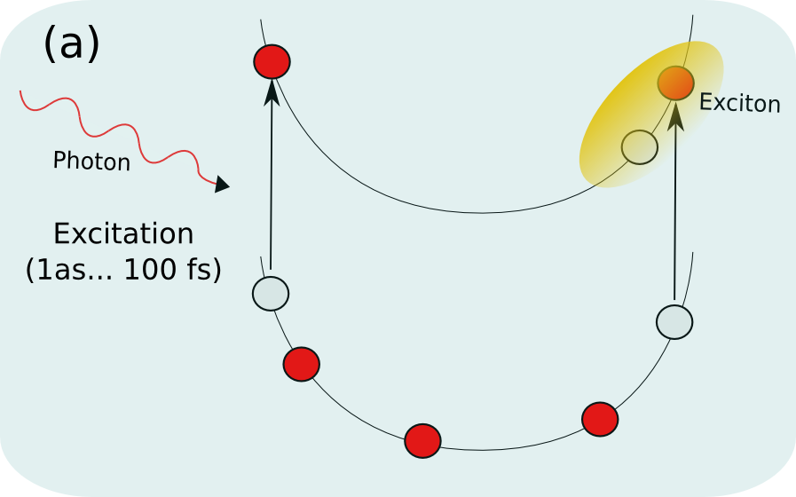Figure 1: Schematic representation of the first stage of the excitation process in a two-band model. The richness of phenomena that can be observed during the relaxation process is linked with the initial carriers population.
Laser durations have been constantly decreased, reaching in 2008 the attosecond[Goulielmakis] domain (10⁻¹⁶ seconds). Nowadays ultrafast and non-linear phenomena represent the most challenging aspect of the emerging field of non-equilibrium physics, that in recent years has assumed a strategical role for its potential application in electronics, optics, biology and medicine.
It is crucial to draw the attention to the fact that the concentration of light in space and time, as achieved in focused ultra-fast laser pulses, can reach power flux densities exceeding 10¹⁸ watts/cm². In order get a feeling of the reached energy scale it is useful to report a sentence of Nicolaas Bloembergen, 1981 Nobel Laureate in Physics for his contribution to the development of laser spectroscopy[Bloembergen]:
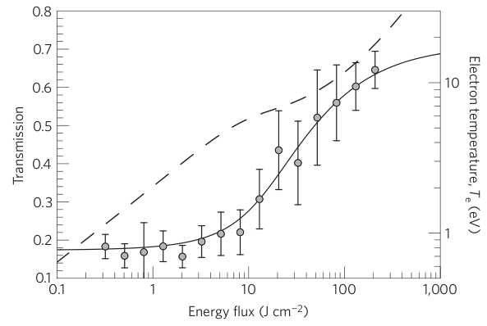Figure 2: Transmission of bulk aluminium as a function of fluence. The circles are the experimental data points. The dashed curve is the predicted electron temperature in electronvolts (right y axis) in the valence band after the X-ray pulse has passed. Taken from [Nagles]
The vastness of the new orders of magnitude in radiative density that have been opened up to experimental investigation by short light pulses may be illustrated by the following observation: the radiative density of blackbody radiation at ten million degrees, corresponding to star interiors, is 10¹⁷ watts/cm².

The first stage that defines a typical experiment performed using ultrafast laser pulses is sketched in Figure 1. The laser pulse with a given photon energy, spectral width and peak intensity creates a certain density of electron-hole pairs in a more or less localized region of space. The density of excited carriers is a central quantity and it depends on the intensity of the perturbing field.
At this stage the role of the electronic correlations is to stabilize the ensemble. We know that the excited carriers are forced by the electronic correlation to form quasiparticles and multi-particle states[Fetter] (like excitons). The complexity of these excitations is directly related to the initial density of carriers.
A very recent experiment[Nagles] well explains the non-conventional properties of this very first state of the system. The idea is very simple: by hitting a system with an intense 15 femtoseconds long X-ray the dominant process activated will be photoionization followed by a radiative recombination of the empty states. If the laser power is high enough to make the rate of photoionization higher than the rate of recombination the aluminium inner shells absorbers turn out to be severely depleted. Because of a so large density of carriers aluminium becomes transparent, as shown in Figure 8.
The X-ray induced transparency of metals like aluminium is linked to a gap opened in the electronic states. As a direct consequence the metallic screening is destroyed and the electronic correlations creates multi-particle excitations. These excitations make the system transparent for a short time (of the order of ps) after which coherence is destroyed by dissipation.
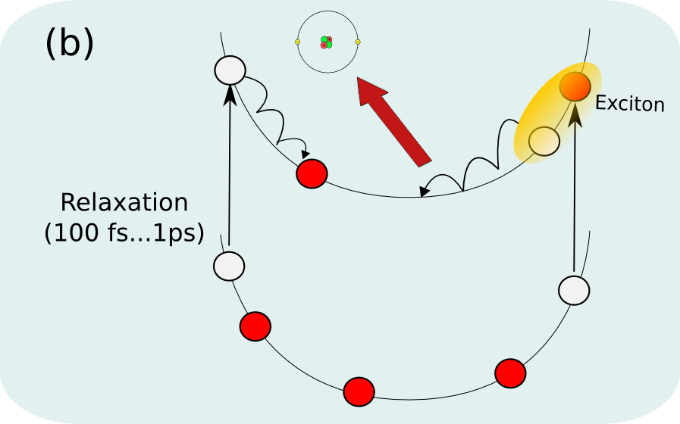Figure 3: During the relaxation process electron-phonon scattering will gradually destroy the coherence of the multi-particle states created by the primary excitation.
This experiment and other similar experiments inspired the present proposal (VELOCE).
A central role on the VELOCE project is played by the instantaneous state of the material immediately following the laser pulse excitation, to which we will refer as the INitial Ensemble of excitationS (INES). The INES can be experimentally characterized by different energy and spectral distributions. Nevertheless, only recently, thanks to experiments like the one on solid aluminium the extraordinary potentialities of this state, linked to the physics of its relaxation, start to be disclosed.
We have a rather poor knowledge of the even most basic properties of the INES (like electronic spectrum, for example) even if experiments provide indirect evidences of a complex interplay of correlation, de-phasing, recombination. How the system will subsequently evolve into an equilibrated state is still an open question.
By reaching the attosecond regime experiments are step-by-step approaching the very initial stage of the INES relaxation. The INES, indeed, cannot be considered as a steady-state as the formation of correlated states is not instantaneous. In a regime of low carrier density, for example, we know that the dressing of particles in GaAs occurs in a time-scale of the order of femtoseconds[Huber].
The carrier density dictates the level of complexity of the INES excitations. In the low density limit, where the linear response regime occur, the electron-electron interaction leads to the formation of bound states, excitons[Onida], composed of one electron and one hole. Increasing the carrier density the electron/hole pairs collapse in a variety of excitations composed of multiple electron-hole pairs, phonons, plasmons. This zoology of excitations defines the characteristic coherence lengths of the system which, in turns, define the stability of the INES during the relaxation.
After the creation of the initial carrier density (Figure 1) the time evolution of the single-particle and many-particle excitations is now governed by a non-trivial interplay between phase coherence and energy relaxation. Indeed, scattering processes tend to destroy the coherence, leading to a de-phasing of the excitations (Figure 3).
De-phasing will be driven by different phenomena. One of the most important is the energy transfer to the atomic motion. In the extreme case as for example in the aluminium experiment, the high temperature per electron reported in Figure 2 points to an highly unstable state that can even lead to the sample melting.
The final process represented in Figure 5, the emission of a longer wavelength photon and return of the system to the ground state, occurs on the relatively long time scale of nanoseconds (>100 picoseconds).

The question now is: what makes the description of the INES dynamics relevant to nanostructures ?

Figures 1,3 and 5 give a simple but clear picture that shows how the phenomena commonly observed experimentally are linked to the initial properties and to the relaxation dynamics of the INES. The ultra-fast optoelectronic properties of the nanostructure perturbed by a laser pulse are, therefore, dictated by the carrier population, de-coherence time, spin correlation and, more in general, by the peculiar characteristics of the INES. In this respect the incredible advance of experiment techniques are inevitably highlighting the limitations of the state-of-the-art theoretical tools. When a large carrier density is created theoretical approaches becomes inadequate and numerical simulations turn out to be infeasible because of the large number of degrees of freedom.
The up-to-date situation is schematically summarized in Figure 4. The fast development of new experimental techniques and the production of stable nano-scale materials have not been followed by a similar evolution of the theoretical techniques. Indeed, we have theoretical schemes designed to work in the extreme cases of isolated molecules or in the case of the axiomatic homogeneous electronic gas (jellium).
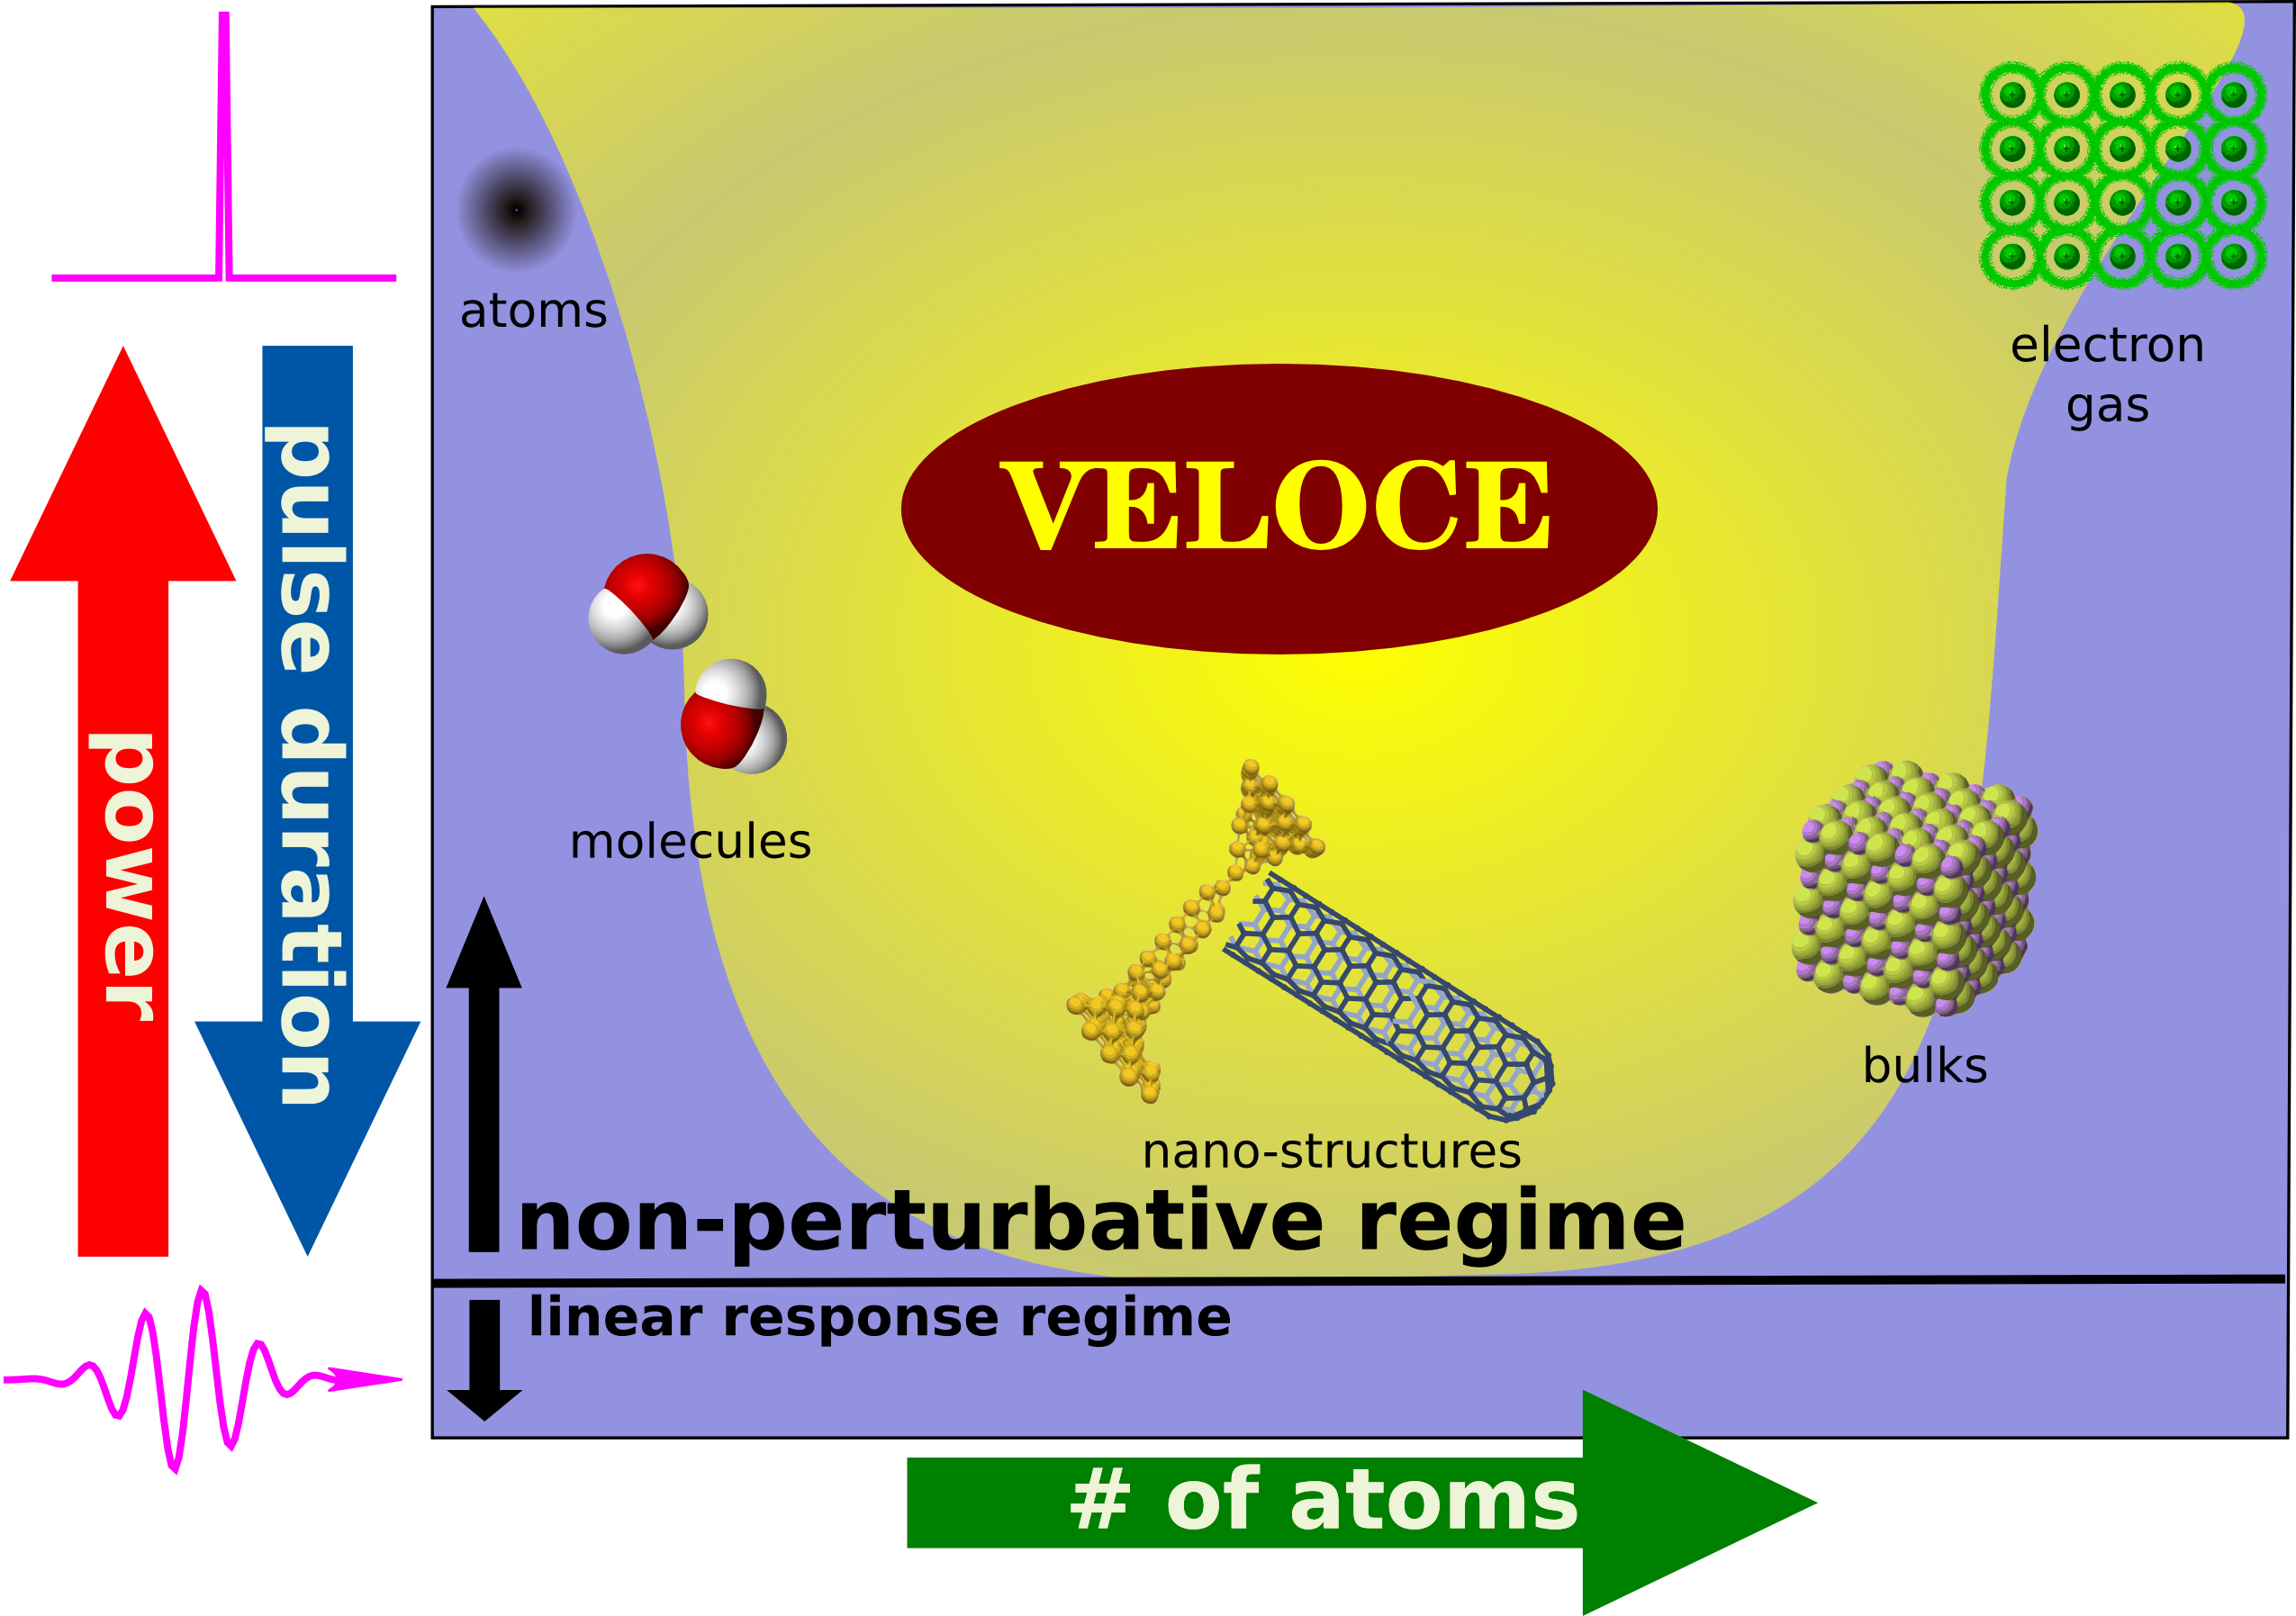Figure 4: The VELOCE project will shine light on a wide regime of laser durations and powers (yellow area) that are beyond the possibilities of the state-of-the-art theoretical approaches (violet area). In particular, this will open new research horizons in the realm of nanostructures.
In the case of molecular systems the reduced number of degrees of freedom allowed to developed a large class of techniques based on multi-configuration approaches. However these methods cannot deal with long-range excitations like plasmons, quasiparticles or excitons present in extended systems as nanostructures. Moving to the the case of systems with an infinite number of atoms we have bulks. Already for simple bulks numerical simulations have hardly investigated the case of laser powers beyond the linear response regime. Presently we have a accurate understanding of the dynamics involving a single electron and single hole and the problem to solve is already cumbersome. The dynamics of more that two particles (hole and electrons) is practically unsolvable and the commonly used approaches are based on the introduction of effective models which are expected to work only for low carrier densities.
The system that plays the same role of simple atoms and molecules in the this regime is the homogeneous electron gas (jellium). In the jellium the atoms are replaced by a jelly of positive charges whose only effect is to neutralize the system. The removal of the atomic structure makes possible to largely simplify the theoretical and numerical formalism. Indeed the jellium model has been used as a first testing-ground of non-equilibrium theories and to simulate the non-linear properties of highly homogeneous systems.

Then we have nanostructures. These are highly inhomogeneous systems constituted by hundreds of atoms. Their peculiar properties are indeed related to the reduced dimensionality, atomic conformation and stability. In Figure 4 nanostructures define a wide regime of laser durations and powers that are beyond the possibilities of the state-of-the-art theoretical approaches. The large number of atoms makes impossible to use approaches borrowed from the molecular physics. The crucial atomic structure rules out the results obtained with the jellium or with few bands models.
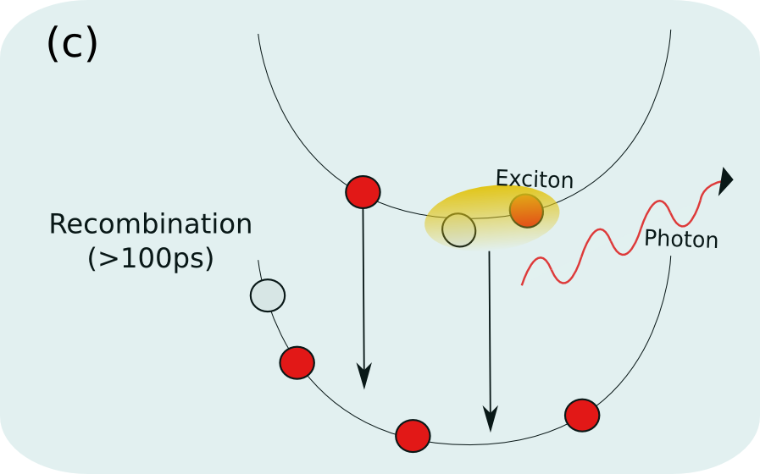Figure 5: Recombination and light-emission in a two-band model.
The final consequence is that entire aspects of the ultra-fast and non-linear physics of nano-scale systems are still grounded only on experimental results, their interpretation being well beyond the capabilities of the state-of-the-art theoretical approaches. Consequently, the theory is deprived of its predictive aspiration, and of the possibility of inspiring new experiments and practical applications. Instead, the continuous advent of more refined and accurate experimental techniques is unavoidably creating a gap between theory and experiment, that the VELOCE project aims to fill.
The VELOCE project aims to investigate the potentialities connected to the use of ultra-fast and ultra-strong laser pulses in nanostructures by interpreting existing experimental results and, more importantly, by investigating new power and duration laser regimes. We will therefore both support the experimental evidences and propose new observable phenomena.

État de l'art et position de la proposition de projet/state of the art and positionning of the proposal

(b) State-of-the art: theoretical models and the Ab-Initio approaches
The intrinsic, composite and exotic nature of the INES makes impossible to use systematic approaches to solve and interpret its dynamics. This can be readily understood by using simple physical arguments. In the Many-Body picture[Fetter] any excitation corresponds to a specific Green's function(GF). For example, the single particle GF,, describes the time-propagation of and electron surrounded by a cloud of secondary electrons excited by means of multiple collisions. These electrons will be balanced by an equal number of holes as the Coulombian interaction is not charged. If the collisions are assumed to be weak (for example because of the low carrier density) the cloud can be described by a sum of single electron-hole pair excitations.
In turn, the dynamics of these pairs is described by a two-body GF, . Assuming, again, a dilute system the equation of motion for will involve the creation of other two electrons and two holes, described by the four-body GF, . The message is then clear: to describe a n-th order excitation it is necessary to introduce an equation containing, at least, (n+2)-th GFs.
This scheme produces a hierarchy of equations, that can be well represented by the master equation
(1)
whose solution is practically impossible without adopting some approximations. The functional represents a complicate dependence that can be revealed by writing the master equation order by order. The external potential represents the laser pulse (eventually a second potential can be added to reproduce the probe field in a pump-and-probe experiment). represents the Hamiltonian of the nuclear motion and includes the interaction with the electrons.
The approaches that have been proposed to reduce the master equation to a treatable problem can be divided in two main categories: the Quantum Chemistry methods and the approaches based on the Many-Body Perturbation Theory (MBPT). These two categories reflect the distribution of available approaches summarized in Figure 4, confined in the two extreme limits represented by molecular systems and jellium models.
In quantum chemistry, the restricted number of degrees of freedom has permitted to introduce a zoology of perturbative approaches (MP2, CI, CIS CASPT2, CASSCF etc..)[Grimme]. These methods are based on the multi-configuration expansion of the electronic wave-function and have been used, for example, to investigate the light-induced dynamics of complex biological molecules as rhodopsion[Frutos]. They become quickly not feasible as soon as the number of atoms and of electronic configurations increases, as in nanostructures.
In the case of homogeneous systems or simple two-band models MBPT has provided an efficient approach to the describe, at least qualitatively, the non-equilibrium processes induced by a laser pulse. Two-bands models[Inagaki] have been frequently used to explain luminescence experiments in bulk systems. In particular, it was possible to clarify different relevant aspects of light emission as: optical Stark effect in coherently driven excitonic systems[Schmitt-Rink], gap shrinkage due to the enhanced electronic screening[Ropke] and Pauli blocking[Kilimann]. When the perturbing field is weak, the INES is well approximated by a gas of free electron-hole pairs and excitons. This fact has inspired bosonic models that describe the relaxation processes of the INES in terms of excitons only, neglecting the contribution of free electron-hole pairs and other multi-component excitations.
Starting from the middle 90's, Many-Body theory has been gradually merged with the Density Functional Theory in a scheme named Ab-Initio Many-Body Perturbation Theory (AiMBPT)[Onida].
Density functional theory[Gross] (DFT) is an extremely successful approach for the description of ground state properties of electronic systems. The success of DFT not only encompasses standard bulk materials but also complex proteins, nanotubes and, in general, nano-scale and atomic-scale systems. The main idea of DFT is to describe an interacting system of fermions via its density and not via its many-body wave function. For N electrons in a solid this means that the basic variable of the system depends only on three - the spatial coordinates x, y, and z - rather than 3N degrees of freedom.
At difference with any other approach DFT relies on the microscopical structure of the material, starting from its atomic configuration. DFT is, thus, universal, in the sense that it is predictive and does not require any input parameter. The outstanding impact of DFT on the today's understanding of the electronic and structural properties of interacting electronic systems was recognized by the Nobel Prize in chemistry given to Walter Kohn in 1998. The drawback of DFT is that it is a ground state theory. For this reason MBPT has been merged with DFT; to use the predictability of DFT together with the strength of the Many-Body approach in order to access the excited state properties of complex materials.
The key idea of the AiMBPT is the introduction of the self-energy operator. For any order Green's function it is possible to define a self-energy that contains informations about the contribution of higher order Green's functions. The connection between MBPT and DFT in the AiMBPT relies on the zero-order energies and wave-functions, calculated ab-initio using DFT, that are used to define the Green's functions and the self-energy. As a consequence the AiMBPT is a parameter-free theory that is nowadays the most predictive tool to describe the low-energy and steady excited state of wide range of different materials[Onida].
The AiMBPT approach is, however, valid only in equilibrium conditions and in the regime of low-power and long laser pulses. In practice it has been used only below the perturbative threshold which, in Figure 4, defines the linear-response regime. Ultra-fast and non-linear phenomena are ruled out.
The state-of-the-art situation is, therefore, summarized as follows. We have efficient schemes to describe real-time dynamics in molecular systems or homogeneous electron gases, while nanostructures can be tackled only in the linear regime through the AiMBPT approach.
The question is then how to extend the predictability of DFT and the strength of the Many-Body approach in the non-equilibrium regime of complex nanostructures ?

Objectifs et caractère ambitieux et/ou novateur de la proposition de projet / Objectives, originality and/ or novelty of the proposal
A new theoretical approach: the ab-initio theory of non-equilibrium dynamics (aiNED)
In all situations where non-equilibrium phenomena are present, as ultra-fast excitations, light-emission and non-linear optics, the standard tools of standard AiMBPT becomes inadequate. A generalization of the MBPT to non-equilibrium systems has been proposed by Kadanoﬀ, Baym and Keldysh[Kadanoff]. In their seminal papers the authors derived a set of equations of motion for the real-time Green’s functions, the Kadanoﬀ–Baym equations (KBE), that are the basic tools of the Non-Equilibrium Green's Function(NEGF) approach. The KBE has provided essential progresses in non-equilibrium statistical mechanics.
Both the standard MBPT and the NEGF theory are based on the Green's function concept. As previously discussed this functions describe the time propagation of elemental excitations under the action of an external perturbation. In the steady state MBPT the overall energy is conserved and, as a consequence, the relevant variable used to calculate the Green's functions is the frequency,. Instead, in the NEGF approach energy is not necessarily conserved, due to the coupling with the external field. Consequently the time variable acquires a special role and much more attention is devoted to the time propagation properties. This different perspective marks the difference with the standard, equilibrium MBPT. The time propagation avoids the explosive dependence of the AiMBPT on the high order Green's functions[Kadanoff]. Moreover the KBE are not perturbative in the external field therefore weak and strong fields can be treated on the same footing.
As a first step to tackle non-equilibrium processes in an ab-initio manner is to rewrite the KBE using as a reference system the DFT Hamiltonian. To this end we consider a system evolving under the Hamiltonian
where represents the external laser field.includes the DFT non-interacting contribution () plus the electron-electron interaction,. Thanks to DFT embodies all the informations about the atomic structure and provides, as we will discuss in the following, the link between electronic and atomic dynamics. It is further assumed that the non-equilibrium part vanishes for times . The non-equilibrium part is, in the context of the present proposal, the interaction of the carriers with a laser pulse. Before the perturbation is turned on, the system is described by the thermal equilibrium density matrix
The task is to calculate the expectation value of a given observable, to which one associates a quantum mechanical operator , for times:
The subscriptindicates that the dependence is governed by the full Hamiltonian, i.e., O is written in the Heisenberg picture. The NEGF method transforms the time-dependence of with the full Hamiltonian to a simpler form, namely to that of with the stationary part of the Hamiltonian by introducing the concept of contour-ordered quantities:
where the contour is depicted in Figure 6. Thus we can define, like in the AiMBPT approach, a Green's Function with time arguments that respect the contour-ordering. However, since the time labels lie on a contour with two branches, one must keep track of which branch is in question. So we distinguish a greater and a lesser Green's functions characterized by the two possible time orderings: and . This two quantities are also related to the non-equilibrium distribution of electrons and holes in the system. Similarly to the equilibrium case the central ingredient of the NEGF theory is the self-energy . Given an approximation for the self-energy all the physical information will be extracted from the real-time dynamics of the Green's Functions:
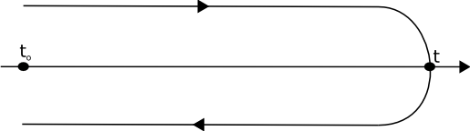Figure 6: The Ct contour.For clarity its branches are shown slightly away from the real axis.
This is one of the KBE, where Σ^{HF} is the Hartree-Fock self-energy and contains all the correlation effects beyond Hartree-Fock. A similar equation is satisfied by. From the solution of these equations we obtain and as function of time, that allow to evaluate the average of any single-particle operator. This will create the connection with a wealth of physical observables.
The simulation of realistic systems using the NEGF method has been considerably demotivated by memory effects that, in contrast to the case of AiMBPT, naturally appear out-of-the-equilibrium. Indeed, the laser duration defines a characteristic time length that couples with the internal scattering times of the system. In practice the Green's functions will depend on a macroscopic time around which the system will fluctuate because of the quantum interferences. The intensity of these fluctuations defines a characteristic memory of the system and any numerical simulation needs to save a certain amount of the history of the time evolution. In this project we plain to extend the NEGF approach to realistic systems ranging from bulk materials to nanostructures.

New numerical tools and algorithms

All the advances proposed in this project will be implemented in the code [Yambo], whose the principal investigator is one of the developers. Yambo is a multi-purpose code with an highly modular structure. The key ingredients of the numerical implementation of the aiNED method are: the non-equilibrium self-energy, the time-evolution operator, the electronic Green's functions and the atomic dynamics. The modular structure of Yambo will simplify the coding of these different parts by creating new modules and specific interactions with the existing ones.
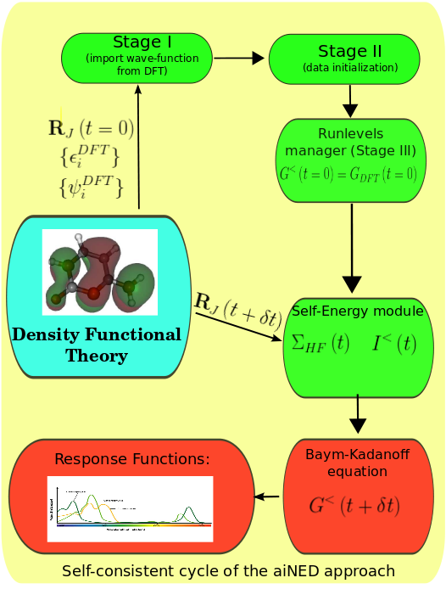Figure 7: Schematic diagram representing the integration of new modules (in red) in the already existing structure of the Yambo code (in green). The definition of the specific actions in each stage of the code can be found in [Yambo]. The arrows represent the numerical procedure used to solve Equations self-consistently.
A schematic description of the expected coding structure is depicted in Figure 7. Thanks to Yambo the VELOCE project will embody the aiNED approach in an highly efficient code. The deep knowledge of the code structure from the principal investigator will strongly reduce the delay between the development of theoretical tools and their testing in realistic materials.
The milestones of the coding part of the VELOCE proposal are outlined in Figure 7. In the first year we plan to code the Yambo modules. At this stage the atomic motion will be included using an electron-phonon interactions[Marini]. The Yambo team is currently collaborating with four super-computing centres in Europe to compile, install and test the code on their parallel machines[SuperComputer]. As nanostructures are extremely demanding to simulate, this collaboration is quite precious and, therefore, the VELOCE project we strengthen the interaction with the Distributed European Infrastructure for Supercomputing Applications (DEISA) (www.deisa.eu).

Programme scientifique et technique, organisation de la proposition de projet / Scientific and technical programme, Proposal organisation

Programme scientifique et structuration de la proposition de projet/ Scientific programme, proposal structure

Objectives
The development of the aiNED approach in a truly ab-initio environment will make possible to investigate, for the first time, the behaviour of paradigmatic nanostructures in an ultra-fast and non-linear regime.
The main motivation of the VELOCE project is that, without a clear theoretical support, the experimental results can offer only a fragmented view of the potentialities linked to the use of ultra-fast laser pulses. Therefore, the practical applications of the aiNED approach, even if inspired by existing experimental results, will explore a wider range of effects and possible applications.
In practice we will perturb selected families of nanostructures with one or more laser fields with variable time length and geometrical conformation. In the case of existing experiment configurations we will interpret the observed results. More in general, we will predict the precise conditions under which new phenomena will be possibly observed. As nanostructures represent the link between molecular systems and bulks our objectives will be inspired by a series of reference experiments, even if relative to molecules or bulks. We will also investigate phenomena that, predicted to occur in model systems, have been never tested and observed in realistic nano-devices.
We will consider three families of paradigmatic nanostructures: nanotubes, nanowires and single layer materials as graphene and hexagonal boron-nitride. All these nanostructures will be considered in a pure functionalized form. The different steps of the theoretical and numerical development, and the practical applications of the VELOCE proposal are organized in two main task. Each task is further divided in milestones distributed along the 36 months of the project. In the first task will be laid the foundations of the aiNED approach by merging the KBE with the DFT. At this stage we will consider non-equilibrium and non-linear phenomena in the steady-state limit of the INES dynamics, including the coupling between electron and phonons. In the second task we will release the steady-state approximation in order to describe the ultra-fast phenomena.

Description des travaux par tâche / Description by task
In this section we describe in details each task and the specific applications we plain to address. A preliminary distribution of the TASKS throughout the project duration is outlined in Figure 10. During the first year the Principal Investigator, in collaboration with the partner member and the VELOCE post-doc students will work full-time to lay the theoretical foundations of the aiNED theory. The early achievements of the TASK1 will allow in make possible to tackle the description of the steady-state phenomena as non-linear optics already starting from the first year. Starting from the second year we will gradually introduce transient effects (TASK2).
The two steps of the aiNED numerical development are also considered in Figure 5. All Yambo modules will be completed in the first two years. In the following sections the different milestones are discussed in detail.

(TASK1) Non-equilibrium steady-state phenomena (Years 1-1.5)
In non-equilibrium steady-state phenomena the physical properties of a material, pumped with a strong and steady laser, are probed by a second weak laser that works in the linear response regime. In this way the electronic, dielectric and vibrational properties of INES can be studied in a quasi-equilibrium limit.
This quasi-equilibrium state of the INES is, in general, characterized by an high density of carriers that have completely relaxed towards a system of multi-particles excitations. Depending on the available carriers the electronic spectrum of the system reveals the existence of quasi-particles, excitons, bi-excitons and even more exotic polaronic (electrons and excitons+phonons) states. The complex equilibrium between the different excitations are the subject of the present TASK. At this stage we will include electronic correlation effects and we will further assume the atoms oscillating around their equilibrium positions. Dissipation will be included in the shape of an electron-phonon interaction[Marini].
Many effects related to the excited state properties of the quasi-equilibrated INES have been observed in bulk systems. We expect that the stronger correlation and smaller electron-phonon interaction imposed by the electronic spatial localization in nanostructures will enhance the observation of these effects and induce new phenomena.

(T1.1) Non-linear optics and Electromagnetically induced transparency (Years 1-1.5)
Non-linear effects are due to the modification of the optical properties of a material by means of a sufficiently intense pumping field. Beyond the larger number of technological applications, non-linear optics represents a key benchmark for the theory and numerical implementation of the aiNED.
At the beginning we will validate our techniques against “simple” bulk semiconductors like GaAs, where there are clear measurements of the non-linear response[Bergfeld]. After this first phase we will move towards nanostructure and in particular nanowires to investigate their potential use as high-harmonic generators[Nakayama].
Non-linear phenomena can be also induced by using two different laser fields. One example is the fascinating phenomena of electromagnetically induced transparency (EIT). This phenomena can be explained by using a simple argument. If the pump laser stops the electrons from moving at the same frequency of the probe field, the material will turn transparent[Harris]. EIT is not only a streaking physical effect but it has important applications in the device of lasers without population inversion, photonic devices or quantum memories for photons[Fleischhauer]. Moreover in 2010, for the first time, it has been demonstrated that slow light and electromagnetically induced transparency can be obtained in a self-contained planar atomic spectroscopy chip[Wu], opening new prospectives to use light in telecommunication and computation. Until now EIT has been obtained using atoms and molecules, mainly because the de-phasing in these material is small compared with the case of solid-state materials. However recently there have been several proposal to employ excitons[Artoni] in bulk semiconductors instead of the atomic transitions. We think that nanostructures, and in particular nanotubes and nanowires, can be even more promising candidates due to the strongest electron-hole binding energy and the smaller de-phasing rate, if compared to bulk semiconductors.

(T1.2) Optical Mott-transition (Years 1-1.5)
When the pump intensity becomes extremely strong light can induce phase transitions in the excited carriers as the pressure or temperature do in solids: this is the so called optical Mott transition[Arno,Kappei]. The idea of a metal insulator transition, due to the variation of the carriers density or of Coulomb interaction, was put forward by Mott in his seminal paper[Mott], and has been very actively studied since. One of the cases of interest, amongst many others, is the case of an optically excited semiconductor where a transition from an insulating exciton-like gas at low densities to a conducting electron-hole plasma at high densities is observed.
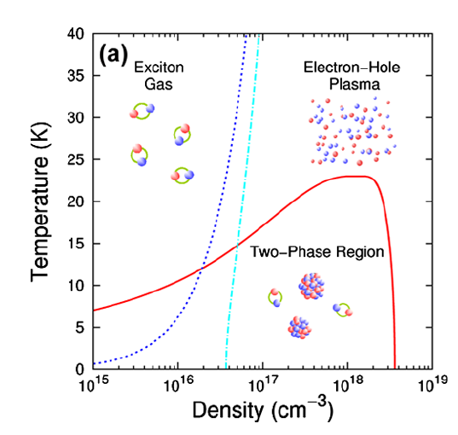Figure 8:Phase diagram of the INES structure as a function of the carrier densty. From Ref. 30
The description and prediction of an optical Mott transition in nanostructures will permit to investigate the intrinsic composition of the INES as a function of the carrier density.
To understand what we expect to find in nanostructures let's consider the simpler case of bulk silicon[Suzuki]. In this case the non-linear regime is reached when the laser induces the formation of 10¹⁵-10¹⁷ carriers/cm³. The experimental results suggest a picture of the INES as a function of the carriers density, schematically represented in Figure 6. The INES switches between different regimes : (i) the excitonic-like, insulating regime, at low temperatures T and carrier densities n; and (ii) the plasma, metallic regime, at high T and/or n; (iii) a two phase region where electron-holes and excitons coexist. A similar experiment carried out in bulk GaAs²⁰ confirms this picture.
The prediction of a Mott transition in nanostructures has a crucial impact on the device of optoelectronic nano-device. Indeed, the light emission, transport properties and lifetime of excitons is quite different from that of electron-hole pairs. Therefore the final macroscopic behaviour of the nanostructure is expected to greatly change in the three phases of a Mott transition. As the laser power and duration are deeply related this has important consequences also for the ultra-fast response of the system.
In this project we propose to use the aiNED approach to explore the occurrence of optically-induced Mott transitions in semiconducting Si and GaAs nanowires. We will study the relative populations of bound and free electron-hole pairs as a function of the carried density and temperature.

(TASK2) Transient effects (Years 1.5-3)
By using ultra-fast laser pulses at the nano-scale it is now possible to probe and to control some of the fastest electronic processes known: the electron dynamics within the atoms. When a material is hit by an intense laser beam, the electrons are excited into high-energy orbitals. Then the electronic dynamics measured by means of attosecond spectroscopy can reveal the elementary processes that determine the physical, chemical and biological properties[Goulielmakis10] of the system.
In this TASK we will study the transient effects occurring in the ultra-short time regime after the primary excitation of the INES. Electron-electron scattering and electron-phonon scattering will be considered in order to have a correct description of the balance between correlation and de-phasing. Thanks to our theoretical approach we will be able to study the dynamics following the initial excitation with an arbitrary time resolution. This tool will be used to investigate fundamental problems as excitons formations and more applicative phenomena as ultra-fast optical switching.

(T2.1) Dressing up of correlation and excitons formation (Years 1.5-3)
In a pump-probe experiments the dynamics of the excitations that constitute the structure of the INES can be studied by looking at some properties related to a delayed probe pulse. The key mechanism in these type of experiments is the use of two laser probes delayed by an amount of time comparable with the characteristic relaxation time of the excited carriers. This lead to the real-time observation of all processes occurring during the relaxation.
In particular, tera-hertz time-domain spectroscopy (THz-TDS) and mid-infrared light sources have been used to study the formation dynamics of excitons in bulk Cu₂O[Kubouchi] and Silicon[Suzuki] and to study the ultra-fast build-up of a plasmons in bulk GaAs[Huber].
Exploring the real-time dynamics with pump-and-probe experiments can access the new physics that is not visible using steady-state techniques. For example in Ref. [Sukuzi] the authors were able to disclose the formation of electron-hole droplets trough nucleation from an excitonic gas in the two phase region of Figure 6. They showed that, at the Mott-transition, droplets condensate, reducing their radius, to form the electron-hole plasma. The complex phase diagram that has been observed in simple semiconductors shows the immense possibilities that these techniques open in the study of nanostructures.

(T2.2) Ultra-fast optical switches and pulse induced transparency (Years 1.5-3)
Many scientists think that photonics will be become for the 21st century what electronics has been for the 20th. In this context also European Community is funding a Network of Excellence, ePIXnet (www.epixnet.org) to develop photonic integrated components and circuits. Switching techniques could also improve today's telecommunications, that nowadays must convert inefficiently light to electricity and then back to light. Under the influence of a laser beam an optical switch exhibits a non-linear response in the sense that transmitted intensity is a non-linear function of the incident intensity. This fact opens the possibility to create a device that acts as a transistor for light, as shown in Figure 9. Prototype optical transistors have been already created in laboratories[Hwang] using a single dye molecule. This device can operate as an optical transistor and coherently attenuate or amplify a tightly focused laser beam, depending on the power of a second gate field. Other types of optical switches respond to external strain, temperature, or to electric current[Peng] and could have various potential applications in sensing. In all these devices the external pump, that can be light, strain, temperature or electric current brings the material in an non-equilibrium state with altered optical properties.
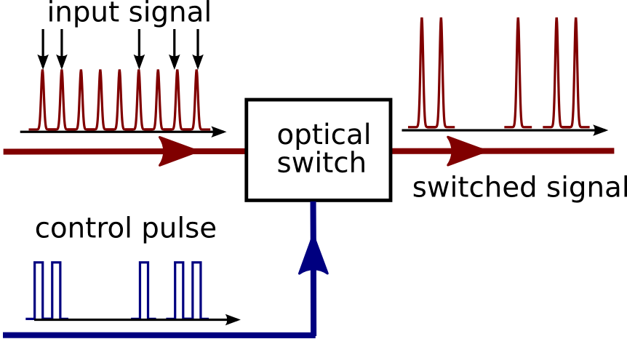Figure 9: Schematic representation of an optical switch.
These properties will be addressed in this milestone, where we will extend the methods developed in (M1.1) to account for ultra-fast transient effects. We will investigate the modification of the dielectric properties when a strong and fast laser pulse is used. In this milestone double walled carbon nanotubes (DWNTs) are particularly relevant, as it has been experimentally shown that they can be excellent ultrafast optical switches[Kamaraju].

Calendrier des tâches, livrables et jalons / Tasks schedule, deliverables and milestones
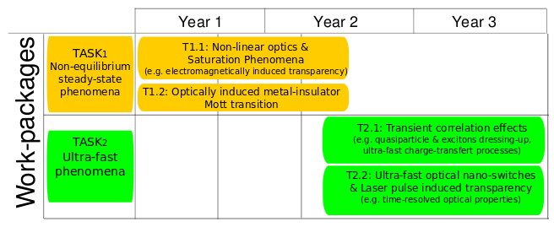Figure 10: Distribution of the VELOCE milestones and numerical coding stages along the project duration.

Stratégie de valorisation, de protection et d’exploitation des résultats / Dissemination and exploitation of results, intellectual property
a) Fundamental science. The possibility to simulate ultra-fast phenomena at nano-scale will be an important test for the approximations common employed in condensed matter many-body theory. Moreover the real-time approach, as it is not limited to the linear regime will allow to study physics regimes difficult to be described with other approaches.

b) Applications. The possibility to study and predict non-linear properties of bulk materials and nanostructures will target experiments towards the most promising materials and devices. The theoretical tools, that we will develop, will be complementary to the experimental experiences. When theory and code will be in a production stage, we plain to start different collaborations with the French experimental community in the Grenoble environment.

c) Codes development and free softwares (GNU/GPL license). The principal investigator of the VELOCE project belong to a the team of developers of the Yambo project[Yambo]. Yambo is GPL FORTRAN/C code for Many-Body calculations in solid state, molecular physics and nano-scale physics. All new advances proposed in this project will be implemented as additional modules of the Yambo code, and will be released under GPL licence after the publications the corresponding articles. This will allow to a large community of users to simulate time-resolved phenomena with an efficient and advanced code. Moreover the YAMBO code is interfaced with ABINT and PWSCF, two DFT codes widely used in the French community, and this will speed up the diffusion of this new tool.

d) Schools and tutorials: we will organize, together with the Yambo team, hands-on and tutorials to disseminate the tools developed in the VELOCE project that, thanks also to DEISA support, will reach a large and variegated community of end-users like physicists, bio-physicists and chemists.

Description du partenariat / Consortium description

Description, adéquation et complémentarité des participants / Partners description and relevance, complementarity

This project will be carried out at the «Neel Institut» by the project leader, Claudio Attaccalite, Valerio Olevano, Xavier Balse and one PostDoc.
The Neel Institute is the ideal environment to develop and apply an ab-initio theory for non-equilibrium phenomena. In fact at present in the institute there are different groups working on non-linear optics, and luminescence in nanostructures. The successful realization of this project will boost collaboration between experimental and theoretical groups not only inside the laboratory but also in the Grenoble environment. The project will benefit of the collaboration and support from all the «Groupe Théorie et Simulation numérique, Institut Néel». Valerio Olevano (CR1) has also a long standing expertise in GW+BSE formalisms based on planewaves [Olevano01]. He is one of the main authors of the code DP, a planewave TDDFT code and he will provide his expertise in the field, his knowledge of the latest algorithms and perform the reference calculations on small systems. Xavier Blase (DR2) is an expert in developing ab-initio codes in real-space[Blase10], he will work, together with the project leader, in transferring to isolated molecules part of the methodology developed for periodic systems in this project.

Qualification du coordinateur de la proposition de projet/ Qualification of the proposal coordinator
The project leader (Claudio Attaccalite) has a long standing expertise both in many-body physics (RVB models) and ab-initio approaches. During his undergraduate studies and his PhD he worked on Quantum Monte Carlo for the study the ground state of correlated systems[Attaccalite02,Casula04,Attaccalite08]. After the PhD he moved in to the field of electronic excitations and during his postdocs in Lille and San Sebastian he learned and developed density functional theory plus many-body techniques in the study of optical properties of nanostructure. He also started fruitfully collaborations with experimental groups involved in ARPES (angle-resolved photo emission spectroscopy) on graphite and graphene in order to interpret their results using an ab-initio numerical approach[Gruenis08]. At present he participates in the developments of two scientific packages: Yambo (http://www.yambo-code.org) an ab-initio many-body code, and TurboRVB (http://turborvb.qe-forge.org/) Quantum Monte Carlo code for Electronic Structure Calculations.

Qualification, rôle et implication des participants / Qualification and contribution of each partner

 | Nom / Name | Prénom / First name | Emploi actuel / Position | Discipline / Field of research | Personne.mois* / PM | Rôle/Responsabilité dans la proposition de projet/ Contribution to the proposal  4 lignes max
Coordinateur/  responsable | Attaccalite | Claudio | CR2 | Physics Theory | 36 mois | Project leader. Wrinting the real-time code; expertise in electronic excitations.
 | Xavier | Blase | DR2 | Physics  Theory | 7 mois | Transfer to molecular system of the non-equilibrium Green's function methodology
 | Olevano | Valerio | CR1 | Physics Theory | 7 mois | Planewave GW+BSE calculations as reference for small molecules.
 |  |  | PostDoc | Physics Theory | 24 mois | Contribution writing the real-time code; applications in non-linear optics and transient phenomena.

Justification scientifique des moyens demandés / Scientific justification of requested ressources

Partenaire 1 / Partner 1 : Institut Neel
Equipment : The simulation community in Grenoble has decided to mutualize part of their computer resources and technical expertise (IRs informatique) in a unique centre through the so-called Ciment project (coordinator Alain Pasturel. See : http://ciment.ujf-grenoble.fr/) Participation to the maintenance and update of the machines is requested with a 10 k€ contribution for the 3 years of the project.
Staff : A post-doctoral fellow is requested for 24 months to work both on the methodology and application of the codes. The ideal candidate should have a strong expertise in condensed matter simulations and code developments

Missions : Most of the “Missions” expenses will be related to participations to workshop, congresses and visits to experts in the field. We request 9 k€ for three years, that is about 1500 Euros/man-year.

Other expenses : Small computer equipment (for the PostDoc), 2 k€ is requested.

Summary Partner 1: 10 k€ (equipment) + 94 k€ (PostDoc) + 9 k€ (missions+school) + 2 k€ (other expenses) = 115 k€ (plus 4 k€ overhead calculated automatically).

Annexes / Annexes

Références bibliographiques/ References
[Arno] A. Arno et al, Journal of App. Physics 101, 081717 (2007).
[Artoni] M. Artoni et al. Euro. Phys. Lett. 49, 445 (2000).
[Attaccalite02] Attaccalite C, Moroni S, Gori-Giorgi P and G. Bachelet Phys. Rev. Lett. 8, 256601(2002)
[Attaccalite08] Attaccalite C, S. Sorella, Phys. Rev. Lett. 8, 256601(2002)
[Bergfeld] S. Bergfeld and W. Daum, Phys. Rev. Lett. 90, 036801 (2003).
[Bloembergen] N. Bloembergen, Rev. of Mod. Phys. 100, 114501 (2008)
[Blase] Xavier Blase, Claudio Attaccalite, Valerio Olevano, http://arxiv.org/abs/1011.3933
[Casula04] Casula M, Attaccalite C, Sorella S, J. Chem. Phys. 121, 7110 (2004)
[Fetter] Quantum theory of many-particle systems. A.L. Fetter and J.D. Walecka, McGraw-Hill (1971)
[Fleischhauer] M. Fleischhauer et al. Rev. Mod. Phys. 77, 633 (2005).
[Frutos] L. M. Frutos, T. Andruniow, F. Santoro, N. Ferre, and M. Olivucci, PNAS, 104, 7764 (2007).
[Grimme] S. Grimme, Rev. in Comp. Chem. 218, 153 (2004)
[Goulielmakis] E. Goulielmakis, et al. Science 320, 1614 (2008)
[Goulielmakis10] Eleftherios Goulielmakis et al. Nature 466, 739 (2010).
[Gross] Density functional theory, R.M. Dreizler and E.K.U. Gross, Springer-Verlag, Berlin, (1990).
[Gruneis08] A. Grüneis, Attaccalite C et al. , Phys. Rev. Lett. 100, 037601 (2008)
[Harris] S. E. Harris, 50, 36, Physics Today (1997).
[Hwang] J. Hwang et al, Nature 460, 76 (2009).
[Huber], Huber, R. et al. Nature 414, 286 (2001)
[Inagaki] T. J. Inagaki and M. Aihara, Phys. Rev. B 65, 205204 (2002)
[Kadanoff] Quantum statistical mechanics, L.P. Kadanoff and G. Baym, W.A. Benjamin, New York (1962).
[Kamaraju] N. Kamaraju et al. Appl. Phys. Lett. 95, 081106 (2009).
[Kappei] L. Kappei et al, Phys. Rev. Lett. 94, 147403 (2005).
[Kilimann] Kilimann, K. Kremp, D. Ropke, G., Theor. and Math. Phys. 55, 611 (1983)
[Kubouchi] M. Kubouchi et al. Phys. Rev. Lett. 94, 016403 (2005).
[Marini] Phys. Rev. Lett. 101, 106405 (2008)
[Mott] N. F. Mott, Rev. Mod. Phys., 40, 677 (1968)
[Nagles] B. Nagler et al, Nature Physics 5, 693 (2009)
[Nakayama ] Y. Nakayama et al. Nature 447, 1098 (2007).
[Onida] G. Onida, L. Reining, A. Rubio, Rev. Mod. Phys.74, 601 (2002)
[Olevano01] V. Olevano and L. Reining, Phys. Rev. Lett. 86, 5962 (2001).
[Peng] H. Peng et al, Nature Nanotech. 4, 738(2009)
[Ropke] G. Ropke, T.Seifert, H. Stolz and R. Zimmermann, Phys. Stat. Sol. (B) 100, 215 (1980)
[SuperComputer] IDRIS (www.idris.fr) France, BSC (www.bsc.es) Spain, CINECA(www.cineca.it) Italy, CORE.SAM (http://core.sam.pitt.edu) USA, Niflheim (http://www.camd.dtu.dk) DK.
[Suzuki] Takeshi Suzuki and Ryo Shimano, Phys. Rev. Lett. 103, 057401 (2009).
[Schmitt-Rink] Schmitt-Rink, D. S. Chemla and H. Haug, Phys. Rev. B 37, 941 (1988).
[Worth] G. A.Worth and L. S. Cederbaum, Annu. Rev. Phys. Chem. 55, 127 (2004)
[Wu] Bin Wu at. Nature Photonics (2010) DOI: doi:10.1038/nphoton.2010.211
[Yambo] Yambo Code: www.yambo-code.org. A. Marini, C. Hogan. M. Gruning, D. Varsano, Comp. Phys. Comm.180, 1392 (2009).

Biographies / CV, resume
ATTACCALITE, Claudio, research at CNRS, Institut Néel, CNRS-UJF, Grenoble.

Experiences professionnelles
2001-2002: Master SISSA, Trieste, Italy (advisor M. Fabrizio)
2002-2005: PhD SISSA, Trieste, Italy (advisor S. Sorella)
2005-2007: postdoc, IEMN, Lille, France (advisor L. Wirtz)
2007-2009: postdoc, UPV, San Sebastian, Spain (advisor A. S. Rubio)
2010 chargé de recherche CNRS, Institut Neel- Grenoble

Administration of science: developer of scientific software: yambo (http://yambo-code.org), TurboRVB (http://people.sissa.it/~sorella/web/index.html)

Key words: Theoretical condensed matter physics and ab initio simulations. Structural,
electronic properties of nanostructured materials. Car-Parrinello molecular dynamics. Quasiparticle excitations within the GW approximation. Electron-phonon coupling. Quantum-monte Carlo, phase diagram electron gas.

Publications : 25 peer-reviewed publications, including Physical Review Letters and Nanoletters, gathering above 460 citations. H factor=10.

Selected recent publications (5):

- Stable liquid hydrogen at high pressure by a novel ab initio molecular-dynamics calculation
Attaccalite C., Sorella S., Phys. Re. Lett. , 100, 114501 (2008)
- Doped Graphene as Tunable Electron-Phonon Coupling Material
Attaccalite C., Wirtz L., Lazzeri M., et al., Nanoletters, 10, 1172 (2010)
- Strong Charge-Transfer Excitonic Effects and the Bose-Einstein Exciton Condensate in Graphane
P. Cudazzo P, Attaccalite C, Tokatly I., et al., Phys. Rev. Lett. 104, 226804 (2010)
- Electron-electron correlation in graphite: A combined angle-resolved photoemission and first-principles study
Gruneis A., Attaccalite C., Pichler T., et al., Phys. Rev. Lett., 100 (037601) 2008
- Impact of the electron-electron correlation on phonon dispersion: Failure of LDA and GGA DFT functionals in graphene and graphite
Lazzeri M., Attaccalite C., Wirtz L., et al. Phys. Rev. B 78, 081406 (2008)

Implication des personnes dans d’autres contrats / Staff involvment in other contracts

 | Nom de la personne participant au projet / name | Personne. Mois / PM | Intitulé de l’appel à projets, source de financement, montant attribué / Project name, financing institution, grant allocated | Titre du projet : Project title | Nom du coordinateur / coordinator name | Date début &  Date fin / Start and end dates
N°
N°

The studies on graphene motivated the 2010 Nobel Prize in Physics awarded to A. Geim and K. Novoselov.

